Contents

Introduction and literature review 3

Methodology 4

Analysis and results 5

Electricity demand projection 5

Site requirement 6

Site suitability analysis 6

General constraints 6

Main constraints 9

AHP 12

Site selection 12

Financial viability analysis 14

Conclusion 16

References 17

# Introduction and literature review

Indonesia is the world top producer of biofuel and top gas supplier to southeast Asia additionally it is the world’s fourth largest coal producer. Indonesia’s has vast potential for renewable energy, particularly in hydro, geothermal, and solar photovoltaic (PV) sectors, due to its natural resources. The current renewable plant is shown in (figure 1) and solar plant is shown in (figure 2)

Under the Paris Agreement, Indonesia has committed to reducing its greenhouse gas emissions by 31.89% through its Enhanced Nationally Determined Contributions (ENDC). Additionally, with international support, the country aims to further extend this reduction target to 43.20%. [1].

To achieve these emission reduction goals, the Indonesian government has set a plan to integrate up to 41% renewable energy into its electricity system by 2030. However, as of 2022, the target set by the government stands at achieving a 25% renewable energy mix by the same year. [2]

This project assumes that future solar power plants may be installed to cover 38% of the projected electrical installed capacity by 2030

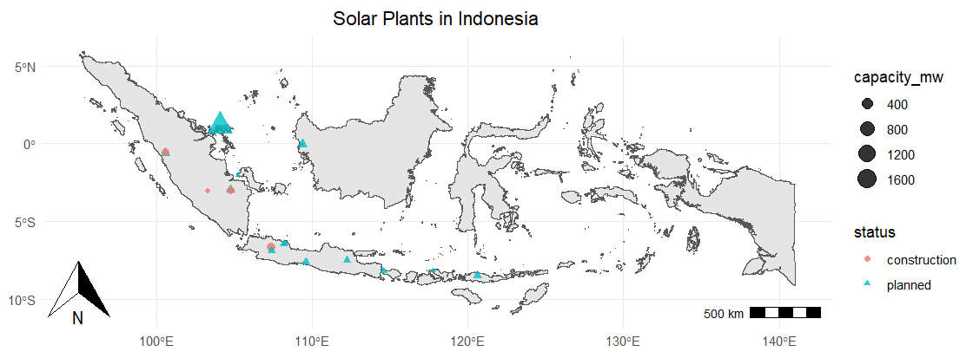

**Figure** **2:** Indonesia solar power plant

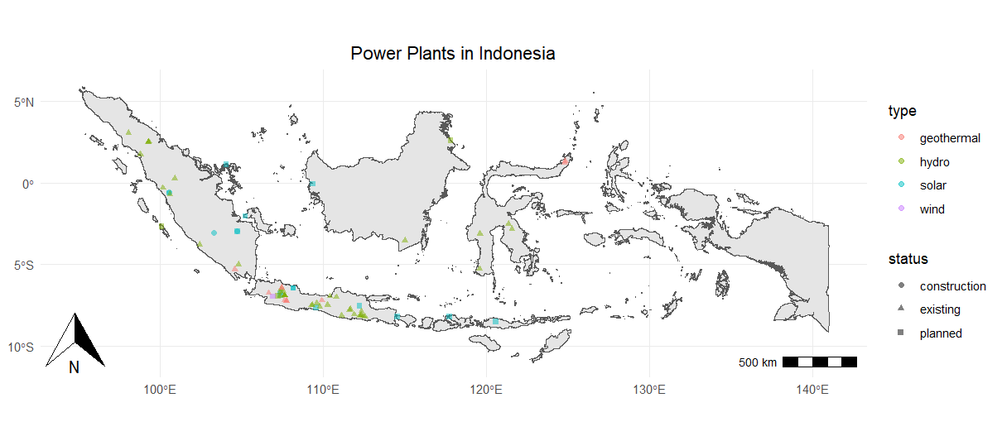

**Figure 1:** Indonesia renewable power plant

# Methodology

This study is focused around five key steps, with the aim of addressing three main questions, as depicted in the (**figure 3)**. The first question focuses on projecting Indonesia's electricity demand by 2030 and determining the contribution of new solar power plants to this demand. To accurately forecast this, the study will analyse essential data points such as population growth and per capita electricity consumption. This approach will enable a precise calculation of future electricity requirements, setting the foundation for assessing the role and capacity of solar power in meeting these needs.

Secondly, solar energy development strategies which primarily focus on determining the optimal number and capacity of solar plants, as well as their ideal locations. This process begins with the evaluation of general spatial resources such as land cover, population density, and peatland characteristics. To further refine potential locations, the Analytic Hierarchy Process (AHP) is applied more critical factors, such as the distance to the power grid and the solar irradiation. Each factor is methodically assessed and weighed against others. This systematic approach facilitates a thorough and unbiased evaluation, leading to the identification of the most suitable sites for solar energy development.

Finally financial analysis, the viability of increasing Indonesia's renewable electricity share through solar power plants by 2030 is assessed. This evaluation looks at the Net Present Value (NPV) and Levelized Cost of Electricity (LCOE) of such an investment. By calculating the NPV, we can understand the projected net earnings over time, considering the present value of future cash flows. Meanwhile, the LCOE provides insight into the average cost per unit of electricity generated, allowing for a direct comparison with other energy sources. This comprehensive financial analysis will determine whether expanding new solar plants is a profitable and sustainable decision for Indonesia's future energy.

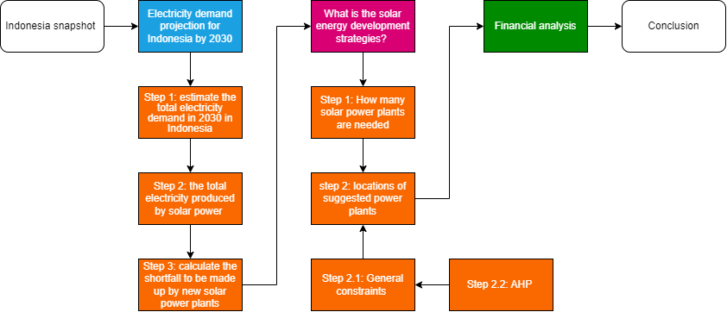

**Figure** **3:** Flow chart

# Analysis and results

## Electricity demand projection

This study assumes the energy demand for Indonesia is driven by electricity consumption per capita and population. Electricity demand can be calculated by multiplying the electricity consumption per capita by population then building a ARIMA model to project the demand for 2030, the ARIMA model is preferred over a regression model because of its flexibility when handling non-linear trend, as ARIMA is specifically designed for time series data. It not only considers the past values but also the difference between values, making it more effective when forecasting data with non-linear trend, The total electricity demand predicted in 2030 is about 438 TWh per year which means 49965 mWh of electricity demand per hour per day.

In this project Indonesia aims to generate 38% of its electricity from solar power by 2030. Using the known capacity factor of 0.24 for solar and calculating the average capacity factor for non-solar is 0.57. The formula Generation = Capacity * Capacity factors can be applied to find the required electricity produced by solar in 2030m which is calculated to be 42GWh Therefore, the new solar power plants Shortfall can be calculated by misusing the current generation from solar plants under planning and construction with the 42GWh to give the shortfall to be about 41GWh.

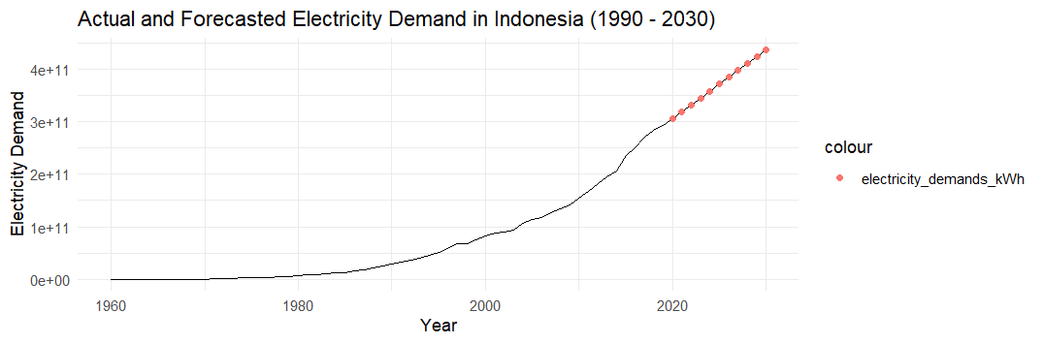

**Figure 6**: Projected electricity demand to 2030

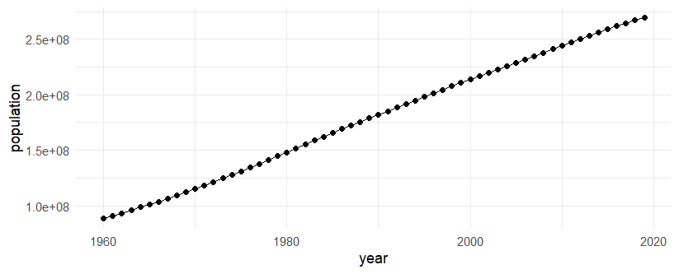

**Figure 4**: Population over time

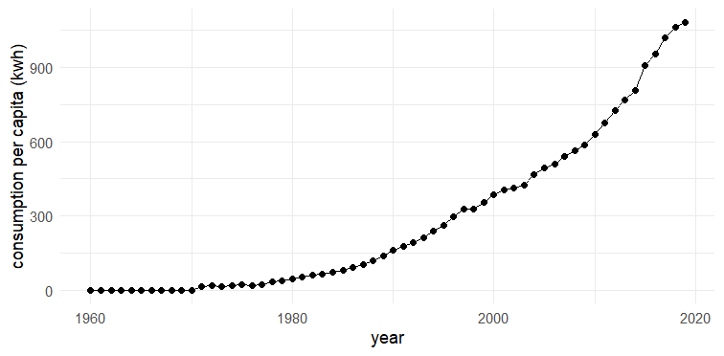

**Figure 5**: Electricity consumption over time

## Site requirement

To calculate the number of solar plants needed and their capacity there a few assumptions to be made when using the equation in (**figure** **7**). First the total area available for all solar plant sites is assumed to be a maximum of 12 km². The baseline for energy production is determined by using the mean irradiation value for 2022, which is 15,647,857. This value is used because during the site selection the solar ssrd will be filtered to be above the mean value, therefore the estimated minimum energy production capacity of each site is calculated to be approximately 5.5 GWh. Based on this, it is determined that to produce the required 41 GWh, a total of 8 solar plant sites would be necessary.

Next to determine the capacity for the 8 solar plants, the generation formula in (**Figure 7**) are required. The calculation assumes an irradiation level of 20,000,000, representing the maximum in Indonesia. This assumption accounts for the variability of irradiation across different locations, ensuring that the generation capacity at each site does not exceed its potential, which is found to be 30GW, this value is above the installed capacity of 47GW stated in the IRENA executive summary report [3][5]

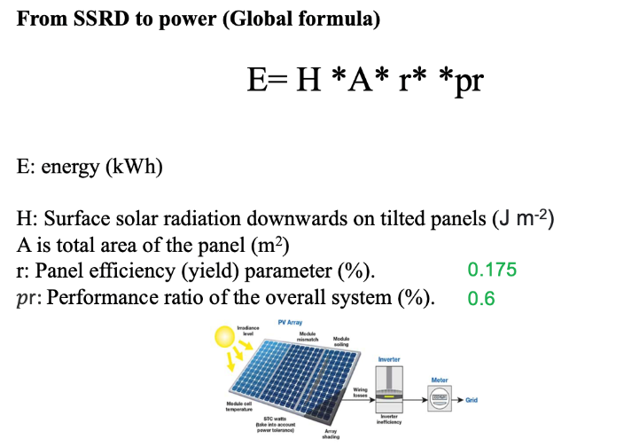

**Figure 7**: Energy formula

## Site suitability analysis

### General constraints

The suitability requirement outlined (**Table 1)** are the essential criteria for selecting general locations where solar plants can or cannot be built upon which leading to the findings in **(Figures 8 to 13)**. These findings are integrated together for later use in identify suitable areas for solar plant construction. The values within each criterion are normalized for clarity and ease of comparison, while preserving their relative differences

**Table 1**

|  |  |  |
| --- | --- | --- |
| **Criterion** | **Suitability requirement** | **Data source** |
| Land cover  **Figure 8** | Less than 15  **Figure 9** | DIVA-GIS[6] |
| Protected areas  **Figure 10** | Not on the designated areas  **Figure10** | Protected planet [8] |
| Peatland  **Figure 11** | No on the designated areas  **Figure 11** | AMERIGEOSS community platform DataHub[7] |
| Population  **Figure** 12 | Less than 1000  **Figure** 13 | DIVA-GIS[6] |

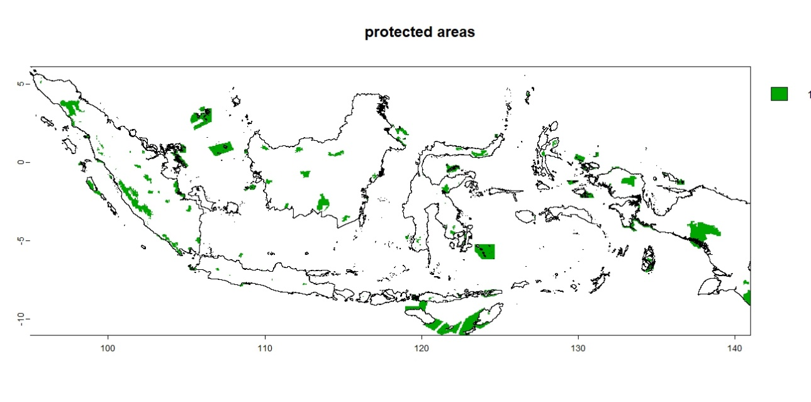

**Figure 10**: Protected areas

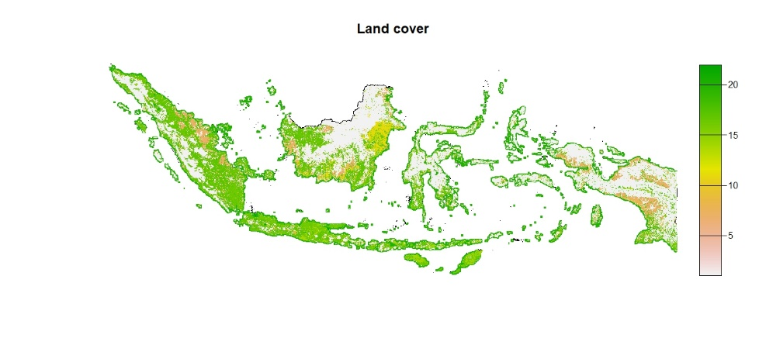

**Figure 8:** Land cover

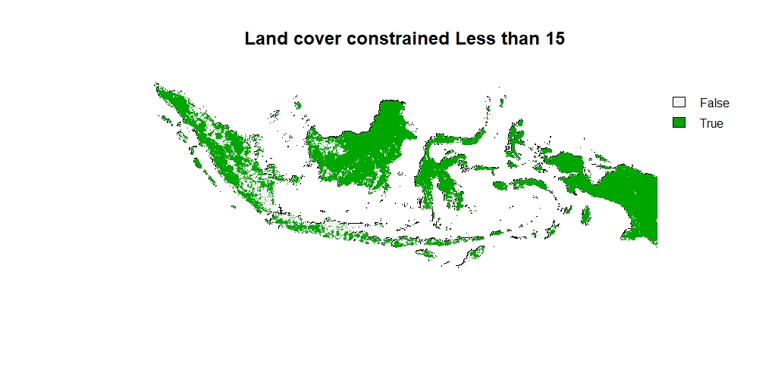

**Figure 9**: Constrained land cover

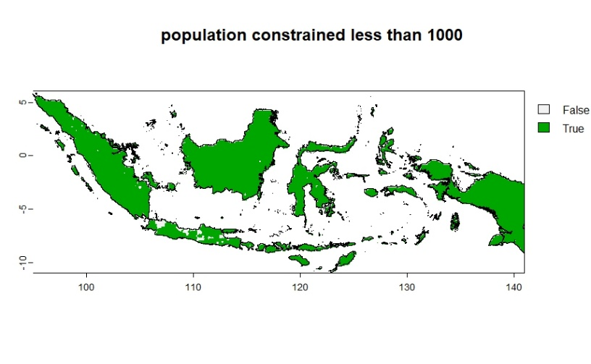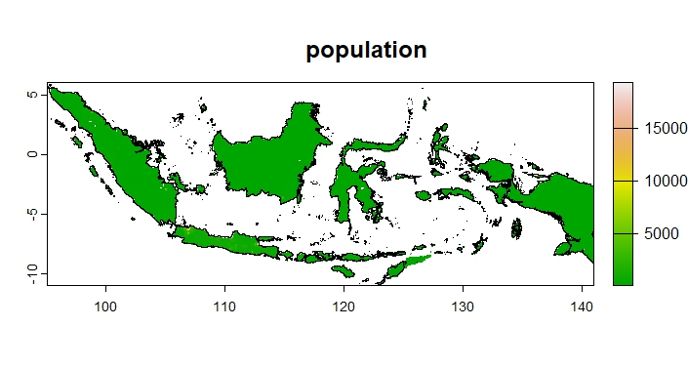

***Figure 13:*** *Constrained**population*

***Figure 12:*** *Population*

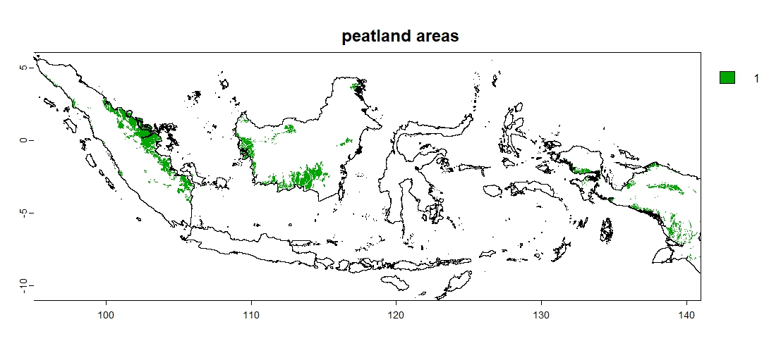

**Figure 11**: peatland areas

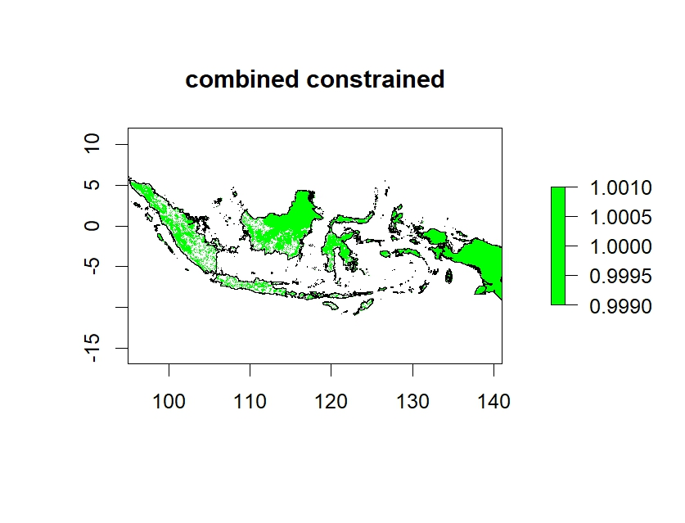

***Figure 13:*** *Combined**constrained.*

### Main constraints

The main criterion in **Table 2** details the critical factors essential for pinpointing more specific locations for solar plants within the general constraints. These factors are employed in the Analytic Hierarchy Process (AHP) to ascertain the most suitable site for the solar plant. The outcomes of this analysis are depicted in Figures X to Y.

***Table* 2**

|  |  |  |
| --- | --- | --- |
| **Criterion** | **Suitability requirement** | **Data source** |
| Distance to grid | Above 1km  Below 5km  **Figure 14** | OpenStreetMap [10] |
| Distance to road | Above 1km  **Figure 15** | DIVA-GIS[6] |
| Elevation/slope  **Figure 16,17** | Below 20 degrees  **Figure 18** | DIVA-GIS[6] |
| Irradiation  **Figure 19** | Above (mean irradiation in 2020)  **Figure 20** | Copernicus Climate Data Store [9] |

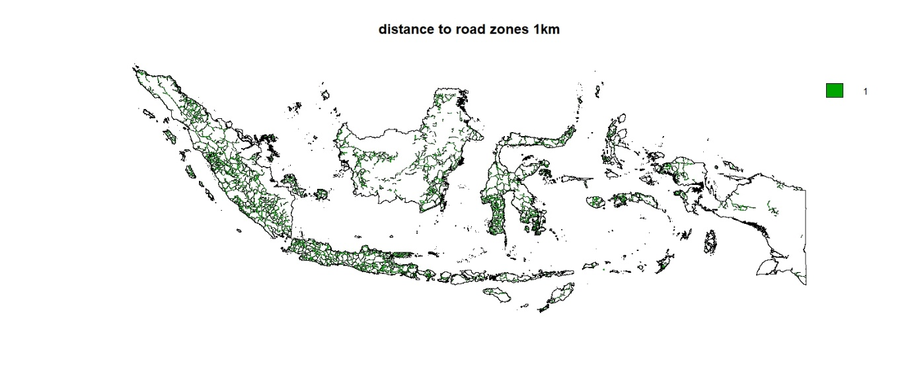

***Figure 15:*** *Distance to road 1km*

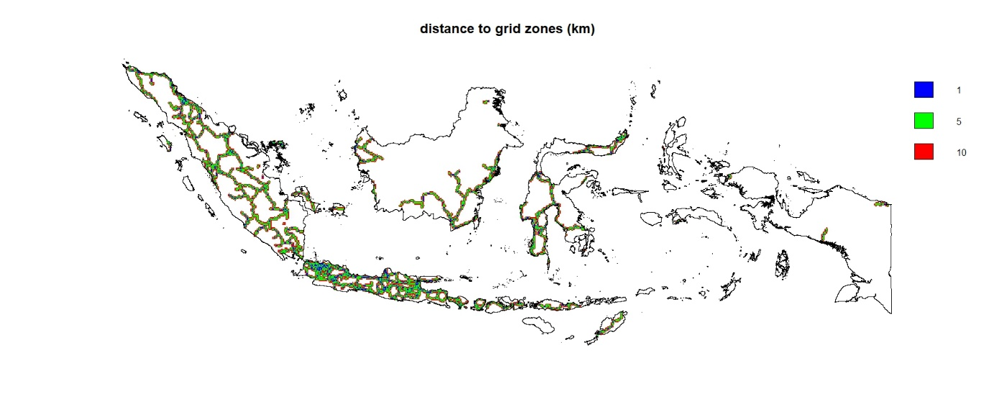

***Figure 14:*** *Distance to grid 1,5,10 km*

***Figure 19:*** *Solar irradiation*

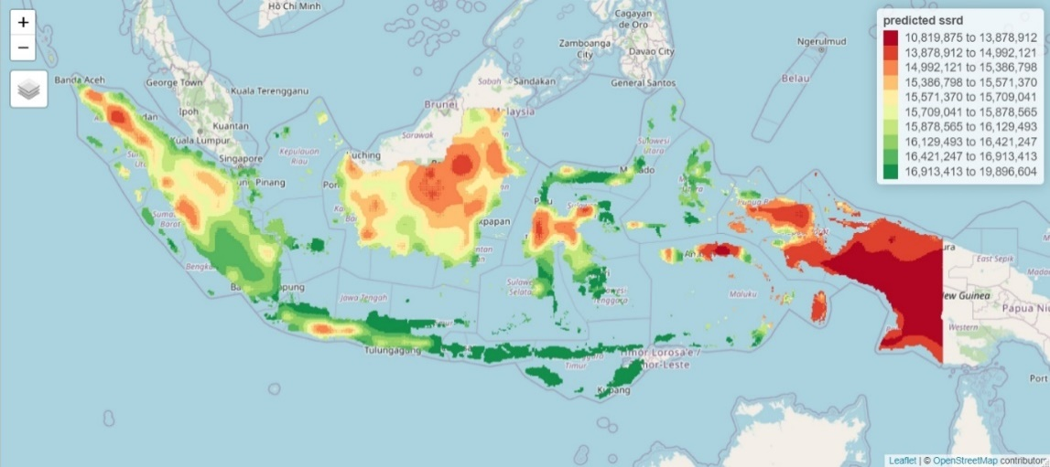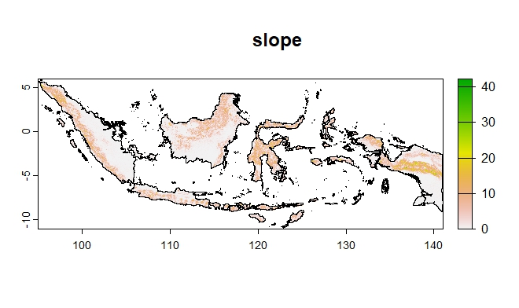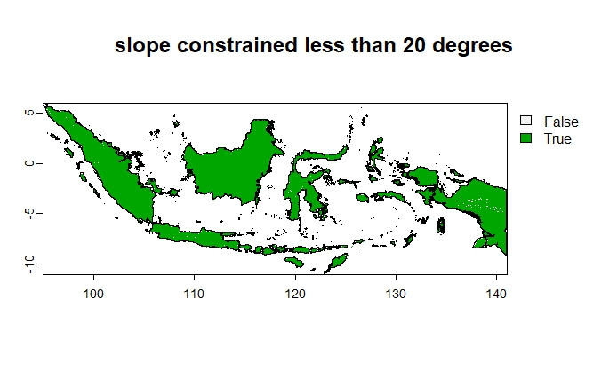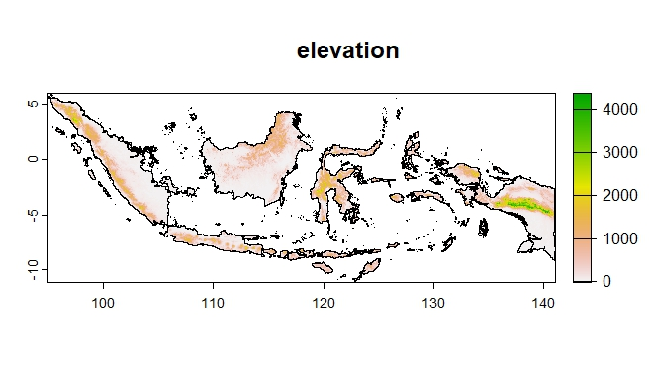

***Figure 16:*** *Elevation*

***Figure 17:*** *Slope*

***Figure 18:*** *Constrained**Slope*

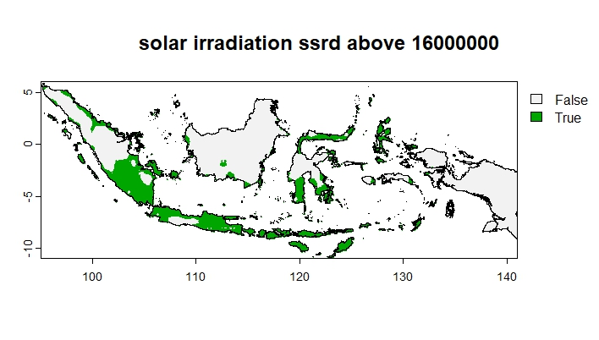

***Figure 20:*** *Constrained**Solar irradiation*

### AHP

The criteria in **Table** **2** are subjected to a pair-wise comparison, with the primary focus being on solar irradiation, followed by distance to the grid, elevation/slope, and lastly, proximity to roads, as indicated in **Tables 3 and 4.** After pinpointing potential locations for solar plants using these criteria, critical weights are applied to these variables. This process helps in identifying the most advantageous locations. Subsequently, by filtering through these locations based on the highest critical weights, a more precise and specific selection of sites for new solar plants is determined.

## Site selection

The filtered analysis yields 51 potential locations, which situates mainly in the Nusa Tenggara (Lesser Sunda Islands) region, due to its high solar irradiation. However, as observed in the **figure 21**, they are clustered closely together. To refine this further, an additional filtering process is applied based on different clusters, selecting those with the highest solar irradiation. This step narrows down the options to the 8 specific locations required, as illustrated in the **figure 22 and 23**

|  |  |  |  |  |
| --- | --- | --- | --- | --- |
| **Table 3** |  |  |  |  |
|  | Distance to grid | Distance to road | elevation | Irradiation |
| Distance to grid | 1.00 | 6.00 | 4.00 | 0.50 |
| Distance to road | 0.17 | 1.00 | 0.50 | 0.13 |
| elevation | 0.25 | 2.00 | 1.00 | 0.17 |
| irradiation | 2.00 | 8.00 | 6.00 | 1.00 |
| sum | 3.42 | 17.00 | 11.50 | 1.79 |

|  |  |  |  |  |  |
| --- | --- | --- | --- | --- | --- |
| **Table 4 normalised** |  |  |  |  |  |
|  | Distance to grid | Distance to road | elevation | irradiation | criteria weights |
| Distance to grid | 0.29 | 0.35 | 0.35 | 0.28 | 0.32 |
| Distance to road | 0.05 | 0.06 | 0.04 | 0.07 | 0.06 |
| Elevation/slope | 0.07 | 0.12 | 0.09 | 0.09 | 0.09 |
| irradiation | 0.59 | 0.47 | 0.52 | 0.56 | 0.53 |
| sum | 1.00 | 1.00 | 1.00 | 1.00 | 1 |

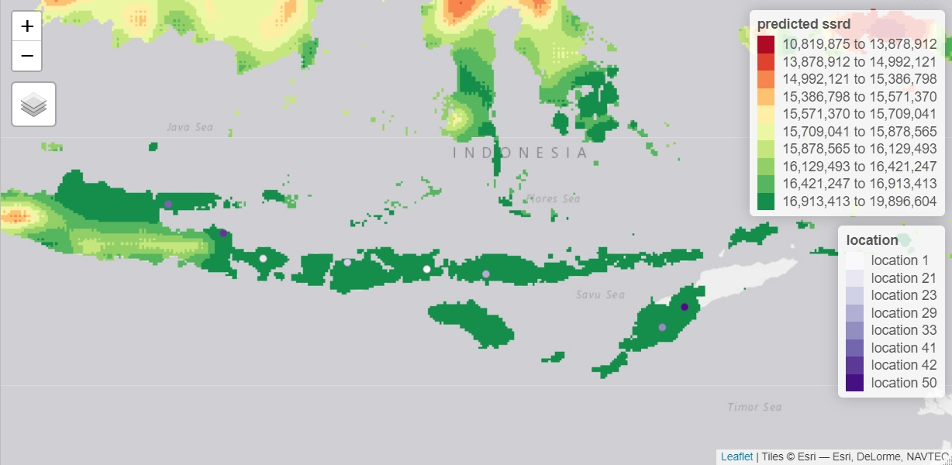

***Figure 23:*** *selected plant and ssrd*

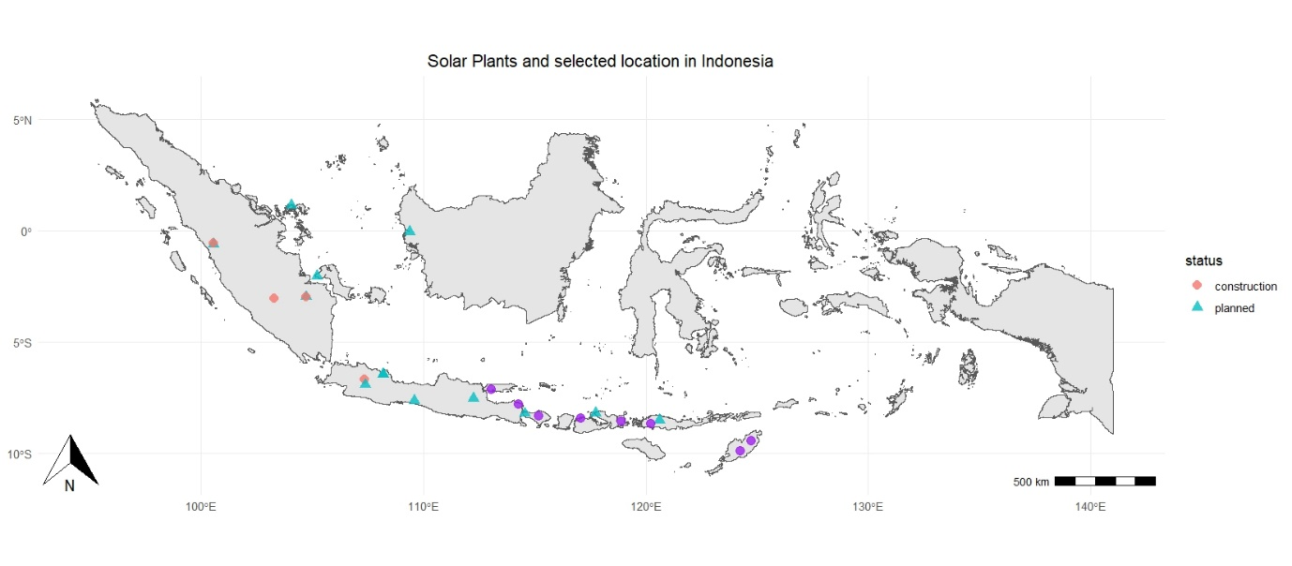

***Figure 22:*** *8 solar plants*

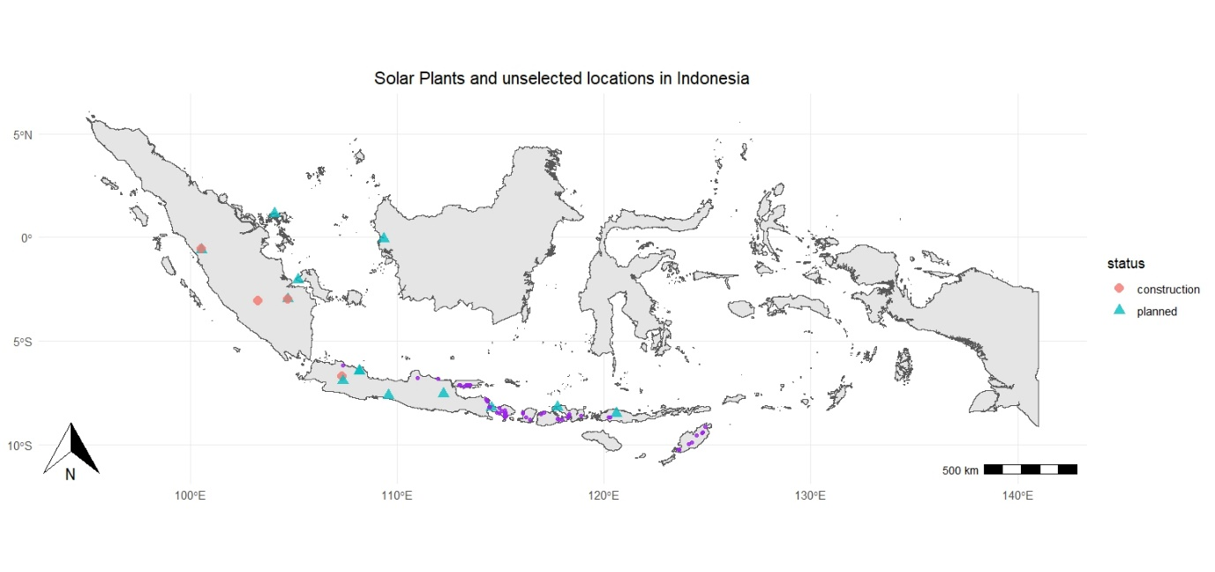

***Figure 21:*** *50 solar plant clustered location*

## Financial viability analysis

To perform a financial viability analysis for a solar power project, several assumptions are necessary for calculating the Net Present Value (NPV) and Levelized Cost of Electricity (LCOE) which are essential metrics in evaluating the project's economic feasibility.

**Initial Installation Cost:** The cost of installing solar power capacity is estimated at $1.16 million USD per MW. For this project the installation capacity is 30 GW for each 8 plants, leading to a significant initial investment.

**Network Connection Cost:** For the network connection, a cost of $590 USD per MW.KM is assumed. Considering the project's criteria that each solar plant location is between 1 km and 5 km from the grid connection point, the maximum distance of 5 km will be used for the calculation.

**Electricity Selling Price:** The assumed selling price of the electricity is 7.67 pence or £0.0767 per kWh which is $0.098 USD per kWh

**Annual Generation:** The total annual electricity generation from the 8 plants is projected to be 226,026,783,192 kWh. This figure is crucial for estimating revenue and calculating LCOE.

**Operational Costs:** It's assumed that the operational costs will be about 1.4% of the total investment, as suggested by MarketWatch [4 ]. These costs include maintenance, labor, insurance, and other expenses associated with running the solar plants.

**Plant Lifespan and Discount Rates**: The solar plants are expected to have a lifespan of 25 years. For financial calculations, the discount rate for NPV is set at 0.05, and for LCOE, it's 0.08.

Using these assumptions, the NPV is calculated in **table 5** to be approximately 2.87E+10 USD. An NPV above zero indicates that the project is financially viable and should yield a net profit over its lifespan.

The calculated LCOE is 0.00729 USD per kWh using the formula below, signifying the average cost per unit of electricity generated, making it a competitive and financially sound project in the current energy market.

$$\frac{NPV}{\sum_{n=1}^{25}{\frac{yearly generation}{{(1+LCOE discount rate - NPV discount rate)}^{n}}}}$$

***Table 5***



# Conclusion

In conclusion, this project provides a detailed roadmap for the development of solar energy in Indonesia by 2030. It successfully determined the projected electricity demand in 2030 for the country and identified the number of potential solar plant along its capacity and size. The project also has pinpointed the location of these plants by utilising methodologies like the Analytic Hierarchy Process, furthermore a detailed financial analysis including NPV and LCOE have showed the economic feasibility and sustainability of expanding solar energy in Indonesia's energy mix. This work lays a solid foundation for Indonesia's transition towards renewable energy, aligning with its commitment to reduce greenhouse gas emissions and meet future energy demands sustainably.

Whilst this project has provided valuable insights, there are areas for further research and refinement and the limitation of this project is the assumptions made such as the assumed capacity of 30 GW for eight plants, each covering an area of 12 km², may be overly optimistic, and the current project bases its calculations for electricity generation on 2022 solar irradiation data, assuming it remains constant until 2030. For future research and future studies, the specific distance from each individual plant to the grid should be included and explored along with a various ranges of plant sizes and capacities to better align with practical limitations and site-specific constraints. Future research should also incorporate a forecast of solar irradiation, utilizing more extensive data and diverse forecasting methodologies to account for potential changes and trends in solar energy availability.

And finally Enhancing Site Suitability Analysis: While the data analytical approach to site selection is effective, it should be complemented with on-ground surveys. Physical site assessments are crucial to validate the suitability of locations, as data may not fully capture site-specific nuances. This will help mitigate unforeseen challenges during construction that could lead to increased costs and project delays.

By addressing these areas, future work can refine the project's assumptions and methodologies, enhancing the accuracy and reliability of the findings and recommendations for Indonesia's solar energy development.

# References

[1]

*Paris Agreement Archives* (no date) *Institute for Essential Service Reform (IESR)*. Available at: https://iesr.or.id/en/tag/paris-agreement-en (Accessed: 13 January 2024).

[2] Simanjuntak, U. (2022) *Renewable Energy Integration in electricity plan can reach 129 GW by 2030*, *IESR*. Available at: https://iesr.or.id/en/iesr-renewable-energy-integration-in-electricity-plan-can-reach-129-gw-by-2030 (Accessed: 13 January 2024).

[3] *Renewable energy prospects: Indonesia*. Available at: https://www.irena.org/-/media/Files/IRENA/Agency/Publication/2017/Mar/IRENA_REmap_Indonesia_report_2017.pdf (Accessed: 13 January 2024).

[4] *How much does a solar farm cost in January 2024?* (no date) *MarketWatch*. Available at: https://www.marketwatch.com/guides/solar/solar-farm-cost/ (Accessed: 13 January 2024).

[5] *Perspectives for the energy transition - irena*. Available at: https://www.irena.org/-/media/Files/IRENA/Agency/Publication/2017/Mar/Perspectives_for_the_Energy_Transition_2017.pdf (Accessed: 13 January 2024).

[6] *Data by country* (no date) *DIVA*. Available at: https://www.diva-gis.org/gdata (Accessed: 13 January 2024).

[7] *Indonesia peat lands - shapefile - AMERIGEOSS community platform DataHub. (beta)* (no date) *Indonesia peat lands - Shapefile - AmeriGEOSS Community Platform DataHub. (BETA)*. Available at: https://data.amerigeoss.org/bg/dataset/indonesia-peat-lands1/resource/2d05afb5-76de-42f1-87b1-d38446815a08?inner_span=True (Accessed: 13 January 2024).

[8] *Indonesia Protected areas* (no date) *Protected Planet*. Available at: https://www.protectedplanet.net/country/IDN (Accessed: 13 January 2024).

[9] *Copernicus Climate Data Store* (no date) *Copernicus Climate Data Store | Copernicus Climate Data Store*. Available at: https://cds.climate.copernicus.eu/cdsapp#!/dataset/reanalysis-era5-land-monthly-means?tab=form (Accessed: 13 January 2024).

[10] *OpenStreetMap* (no date) *Geofabrik Download Server*. Available at: https://download.geofabrik.de/ (Accessed: 13 January 2024).